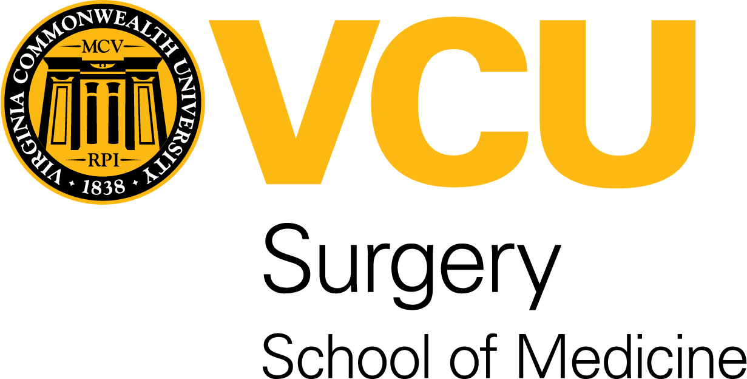

**3nd Annual RVA/VCU Aortic Care Symposium**

**March 1, 2025**

**7:30 am – 4:00 pm**

**Marriott Hotel Richmond (7:30 am-12:00 pm)**

**Sanger 9 (VCU: 12:30-4:00 pm)**

**Keynote Speaker:**

**T. Brett Reece, MD, MBA**

**Director of Thoracic Aortic Program**

**Professor of Surgery**

**University of Colorado**

7:30 – 7:55 am Continental Breakfast

7:55 – 8:00 am Introduction – Daniel Newton, MD and Josue Chery, MD

8:00 – 8:45 am Keynote Speaker- T. Brett Reece, MD-

*Neuro-protection during aortic arch surgeries*

8:50 – 9:10 am Panel Discussion T. Brett Reece, MD, Josue Chery, MD, Daniel Adams, MHS, Aida Sehic, PhD

*Importance of neuro-monitoring*

9:15 – 9:35 am Panel Discussion P. Brody Wehman, MD, Leora Yarboro, MD

*Surgical management of acute aortic dissection (How much surgery do you need?)*

9:40 – 10:00 am Nayef Abouzaki, MD

Outpatient surveillance for chronic aortic aneurysm

10:00 – 10:15 Coffee Break

10:15 — 10:45 am Animesh Rathore, MD

*Options for complex endovascular ascending aortic repair*

10:50 – 11:10 am Panel Discussion Animesh Rathore, MD, Daniel Newton MD, Robert Larson, MD, Mark Levy, MD, Josue Chery, MD

*Is open thoracoabdominal aneurysm repair a dying art?*

11:20 am – 11:50 am T. Panel Discussion Hind Al Saif, MD, Brett Reece, MD, Leora Yarboro, MD, Daniel Newton, MD,

*Repair thresholds for genetic aortopathies*

11:55 – 12:00 pm Conclusion of the didactics

12:00 – 1:00 PM Exhibitors’ Luncheon

12:40 pm- shuttle bus to VCU (Sanger Hall for simulation)

1:00- 3:30 PM Simulation Stations –

* Cardiac – *aortic arch replacement and aortic root enlargement*
* Vascular – *Endovascular fenestration*
* Advanced Practitioner Provider - *Pre-op/Post-op/ICU management case studies*

3:30-4:00 PM shuttle bus back to Marriott Hotel